On-line services and Missed Appointments
Number of Responses: 70

Please complete the following survey and click SEND when you are done. This survey will close on 14th March 2012.

On-line Services
Q1 How useful would you find being able to book and cancel appointments on line?
Very helpful 57%
Fairly helpful 18%
Not very helpful at all 21%
Don't know 2%
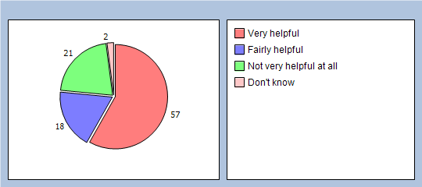
Q2 Would you be interested in being able to order your repeat prescriptions on-line?
Very useful 64%
Fairly useful 14%
Not very useful at all 20%
Don’t know 1%
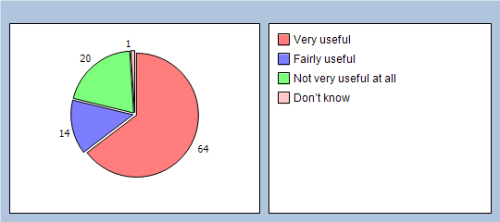
Q3 Would you find it beneficial to have access to the practice newsletter via our web-site with information such as flu clinics and general information relating to the surgery?
Very useful 55%
Fairly useful 20%
Not very useful at all 22%
Don’t know 1%
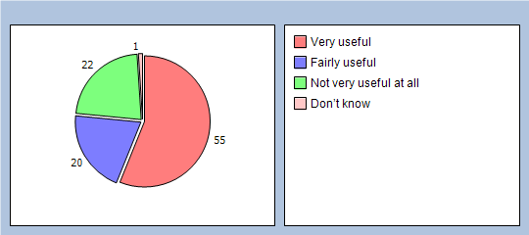

Missed Appointments
Q4 Would you find it helpful to have a text reminder of your appointment date and time?
Yes, very helpful 70%
Fairly helpful 18%
Not very useful at all 7%
Don't have a mobile phone 4%
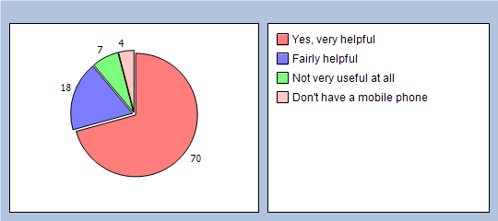
Q5 Do you think it is beneficial to publish the cost to the practice of missed appointments on our web-site and noticeboard?
Very beneficial 55%
Fairly beneficial 31%
Not beneficial at all 11%
No response 3%
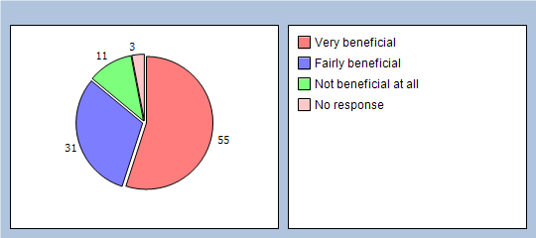
Q6 In the reception area, can other patients overhear what you say to the receptionists?
Yes, but I don't mind 75%
Yes, and I'm not happy about it 14%
No, other patients can't hear 1%
Don't know 7%
No response 3%
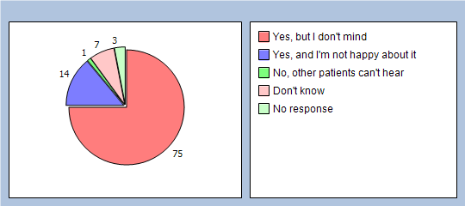
Q7 How helpful do you find the receptionists at the surgery?
Very helpful 97%
Fairly helpful 2%
Not very helpful 0%
Not at all helpful 0%
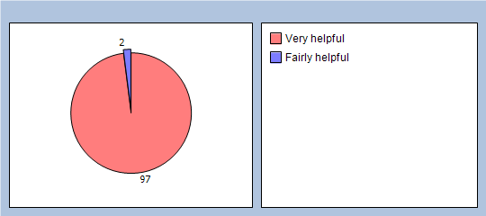
Q8 In the past six months, how easy have you found getting through to the surgery on the telephone?
Very easy 92%
Fairly easy 7%
Not easy at all 0%
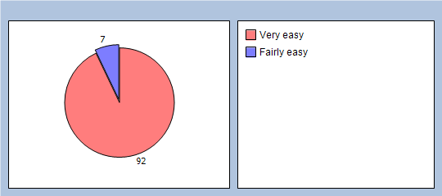
Finally, please add any other comments you would like to make about your GP practice:
Thank you for taking the time to complete this survey, it is much appreciated!

