Survey of GP and Nurses consultations
Number of Responses: 87
Dear Patient,
Many thanks for agreeing to take this short survey to help our practice understand how our GP and Nurses consultation systems can be improved, if at all.
Please answer all of the questions and click 'Send Survey' when you are done.
Q1. Last time you visited the surgery did you see a Doctor, or a Nurse?
Doctor 54%
Nurse 45%
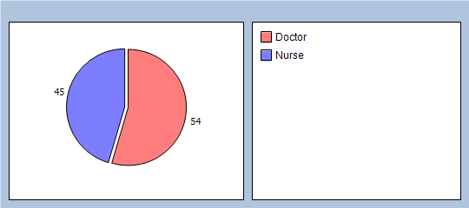
Q2. The last time you saw a Doctor or Nurse at the surgery, how good were they at each of the following?
Giving you enough time
Very good 88%
Good 11%
Neither good nor poor 0%
Poor 0%
Very poor 0%
Doesn't apply 0%
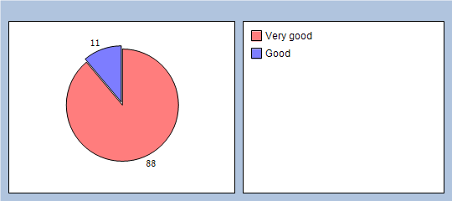
Asking about your symptoms
Very good 80%
Good 17%
Neither good nor poor 1%
Poor 0%
Very poor 0%
Doesn't apply 1%
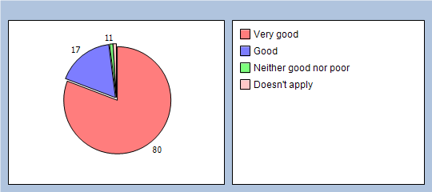
Listening
Very good 81%
Good 14%
Neither good nor poor 2%
Poor 0%
Very poor 0%
Doesn't apply 1%
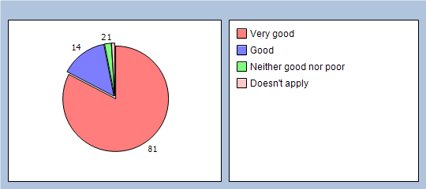
Explaining tests and treatment
Very good 67%
Good 24%
Neither good nor poor 1%
Poor 0%
Very poor 0%
Doesn't apply 5%
No response 3%
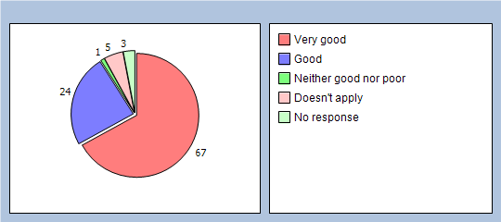
Involving you in decisions about your care
Very good 66%
Good 24%
Neither good nor poor 4%
Poor 0%
Very poor 0%
Doesn't apply 3%
No response 3%
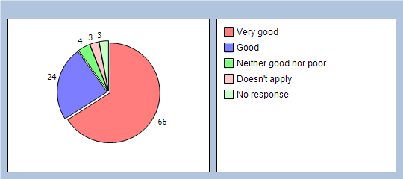
Treating you with care and concern
Very good 80%
Good 14%
Neither good nor poor 2%
Poor 0%
Very poor 0%
Doesn't apply 1%
No response 3%
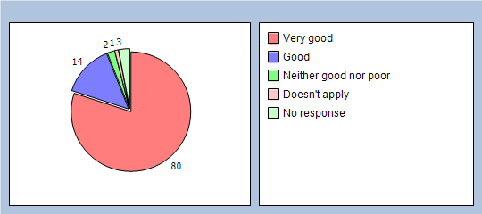
Taking your problems seriously
Very good 77%
Good 17%
Neither good nor poor 1%
Poor 0%
Very poor 0%
Doesn't apply 1%
No response 4%
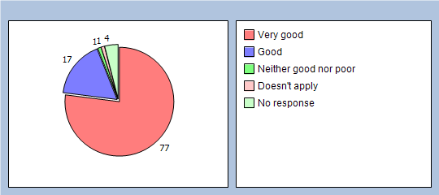
Q3. Did you have confidence and trust in the doctor or nurse you saw?
Yes, definitely 88%
Yes, to some extent 10%
No, not at all 0%
Don't know/can't say 1%
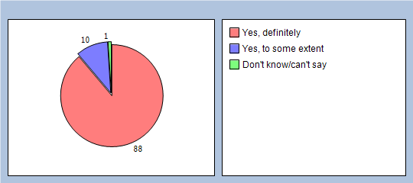
OPENING HOURS
Q4. How satisfied are you with the opening hours at the surgery?
Very satisfied 82%
Fairly satisfied 11%
Neither satisfied nor dissatisfied 2%
Quite dissatisfied 2%
Very dissatisfied 0%
Don't know opening hours 1%
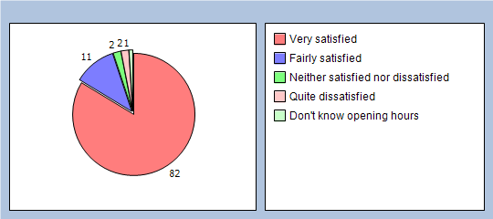
ANY OTHER COMMENTS - Please let us know if you have anything further to wish to add.

To help us analyse your answers please tell us a few things about yourself:
Are you male or female?
Male 33%
Female 64%
No response 3%
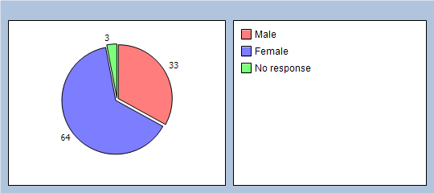
What age are you?
Under 16 1%
17 - 24 5%
25 - 34 11%
35 - 44 14%
45 - 54 16%
55 - 64 22%
65 - 74 22%
75 - 84 4%
Over 84 0%
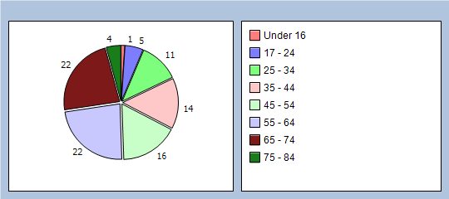
What is the ethnic background with which you most identify?
White British 94%
White Irish 0%
Mixed White & Black Caribbean 0%
Mixed White & Black African 0%
Mixed White & Black Asian 0%
Indian 2%
Pakistani 0%
Bangladeshi 0%
Black Caribbean 0%
Black African 0%
Chinese 0%
Other 1%
No response 3%
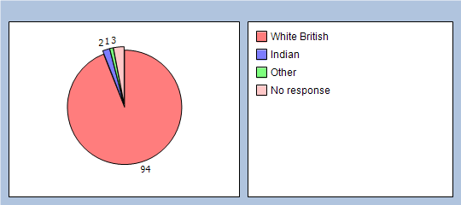
How would you describe how often you come to the practice?
Regularly 39%
Occasionally 45%
Very Rarely 12%
No response 4%
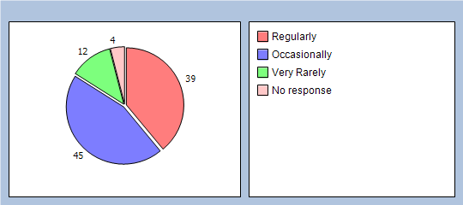
Many thanks for your time in answering the questions on this survey.

